Experiment No. 7
Artificial Neural Network (ANN) using Keras/TensorFlow
Name : Rishabh Ramani
Class : D15B
Roll No : 48
Batch : B

1. Dataset Source
Dataset Name: Churn Modelling Dataset
Source: https://www.kaggle.com/datasets/maulikpatel1930/cricket-world-cup-2023
This dataset is widely used for classification problems involving customer retention and is suitable for training Artificial Neural Networks.

2. Dataset Description
The dataset contains information about 10,000 bank customers, with the objective of predicting whether a customer will leave the bank (churn) or stay.
- Number of records: 10,000
- Number of features: 10 independent variables + 1 target variable

Target Variable (Exited):
- 0 → Customer stays
- 1 → Customer leaves

Feature | Description
CreditScore | Customer's credit score
Geography | Country (France, Spain, Germany)
Gender | Male/Female
Age | Customer age
Tenure | Number of years with bank
Balance | Account balance
NumOfProducts | Number of bank products
HasCrCard | Credit card availability (0/1)
IsActiveMember | Activity status (0/1)
EstimatedSalary | Estimated salary

Dataset Nature:
- Mixed data types (categorical + numerical)
- Requires encoding and scaling
- Moderately balanced dataset

3. Mathematical Formulation of ANN
An Artificial Neural Network consists of layers of neurons where each neuron performs a weighted sum followed by an activation function.

Forward Propagation:
z = Σᵢ wᵢxᵢ + b
a = f(z)
Where: wᵢ = weights, xᵢ = inputs, b = bias, f(z) = activation function

Activation Functions:
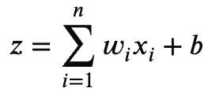
- ReLU (Hidden Layers): f(z) = max(0, z)
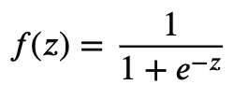
- Sigmoid (Output Layer): f(z) = 1 / (1 + e⁻ᶻ)

Loss Function (Binary Crossentropy):
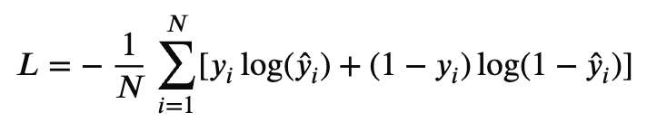
L = -(1/N) Σ[yᵢ log(ŷᵢ) + (1 - yᵢ) log(1 - ŷᵢ)]

Backpropagation (Gradient Descent):
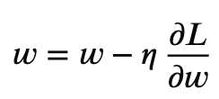
w = w - η (∂L/∂w)
Where: η = learning rate, L = loss function

4. Algorithm Limitations
- Requires large datasets for optimal performance
- Computationally expensive (training time high)
- Prone to overfitting without regularization
- Difficult to interpret (black-box model)
- Sensitive to feature scaling
- Hyperparameter tuning can be complex

5. Methodology / Workflow
- Data Collection: Load dataset from CSV
- Data Preprocessing: Encode categorical variables, scale features
- Train-test split
- Build ANN architecture with Dense layers
- Compile model with optimizer and loss function
- Train model
- Evaluate performance
- Hyperparameter tuning

6. Performance Analysis
Confusion matrix shows:
- True Positives (correct churn prediction)
- False Negatives (missed churn → critical in business)

7. Hyperparameter Tuning
Parameter | Values Tested
Number of layers | 1-3
Neurons per layer | 6, 12, 24
Batch size | 16, 32, 64
Epochs | 50-100
Learning rate | 0.001, 0.01
Dropout rate | 0.2, 0.3

Output - Baseline ANN Model (Accuracy & Loss):
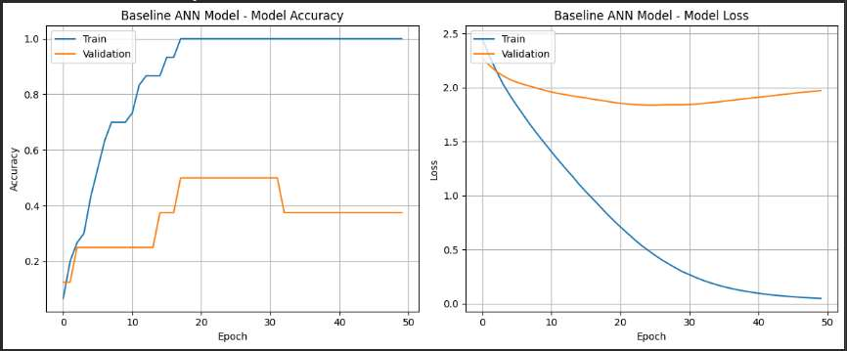
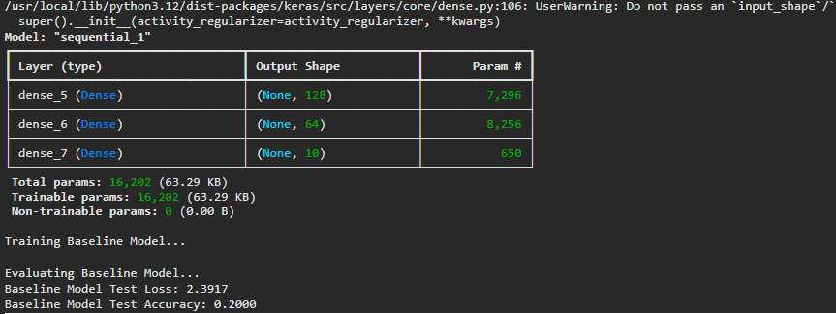

Output - Hyperparameter Tuned ANN & Model Summary:
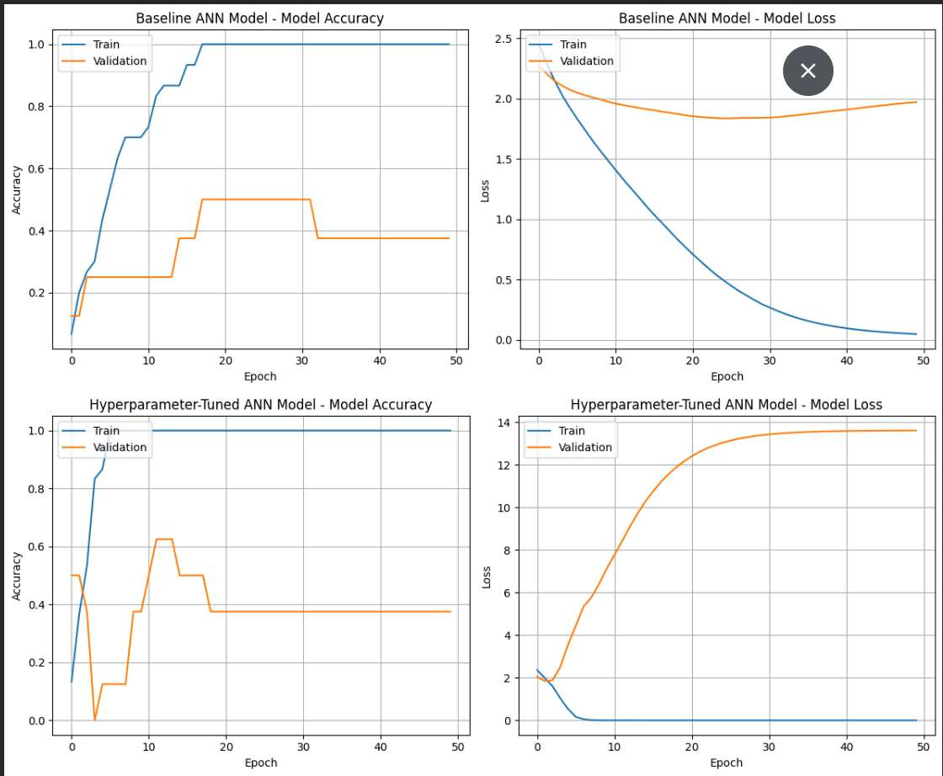

Best Configuration:
- Layers: 2 hidden layers
- Neurons: 12 → 6
- Dropout: 0.2
- Optimizer: Adam
- Epochs: ~70 (early stopping applied)

Techniques Used:
- Manual tuning
- Validation split monitoring
- Early stopping

Impact of Tuning:
- Improved generalization
- Reduced overfitting
- Increased F1 score
- Faster convergence

Conclusion
The Artificial Neural Network successfully models customer churn prediction by learning complex patterns in customer behavior. With proper preprocessing and hyperparameter tuning, the model achieves strong performance and can be applied in real-world banking systems for customer retention strategies.

